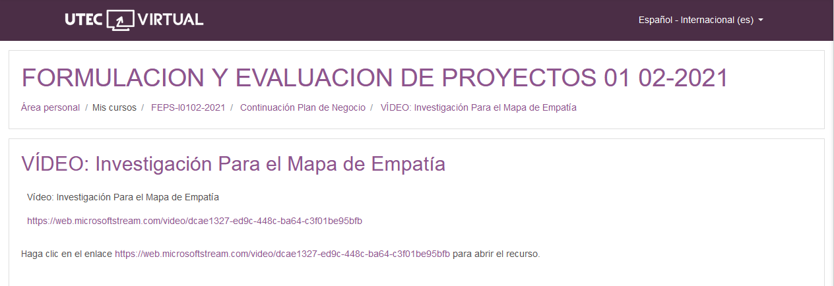https://web.microsoftstream.com/video/dcae1327-ed9c-448c-ba64-c3f01be95bfb

<https://web.microsoftstream.com/video/dcae1327-ed9c-448c-ba64-c3f01be95bfb>